Student ID: 110434301
3/26/2025
Monetary Paper

In recent years, the US economy has faced a period of extreme volatility. This is in part due to the Covid era, which brought in pandemic driven stimulus to levels of inflation not seen in decades. As the market grew more volatile, the Federal Reserve recently responded with historically aggressive policies. One aggressive policy, being high interest on reserve balances, and the other aggressive policy being quantitative tightening. While these measures have begun to stabilize the economy, they seem to have real risk. This paper explores the current economy as a whole, current Federal Reserve monetary policy, and argues for a new monetary policy tool called the strategic supply reserve system. The strategic supply reserve system is a hypothetical policy tool that targets the supply side of inflation directly and could offer a more balanced and resilient path towards price stability
The current state of the US economy and recent years is coming out of a very chaotic state. One common issue that has been plaguing Americans is the issue of increased inflation. What inflation is driven by in an economy is debatable and has been argued by many economists to be different things. Still, in the eyes of the Federal Reserve, they believe that their monetary policies are the core drivers of inflation. A statement released back in January 2012 by the Federal Reserve stated that the “inflation rate over the longer run is primarily determined by monetary policy” (Statement on Longer-Run Goals and Monetary Policy Strategy). Due to this, it seems like current monetary policies might be to blame for this, but the data suggests that monetary policies are currently headed in the right direction. This idea of monetary policy moving in the right direction is best demonstrated in the graph of the median consumer price index. 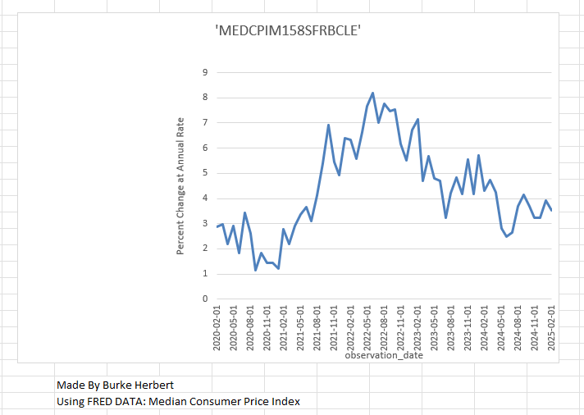This graph shows that there is a huge increase in the percent change at the annual rate of inflation from the end of Covid until around the beginning of 2024. There seems to be a downtick in the inflation rate from January 20, 2014, to July 2024, but as of the most recent percentage, change at an annual rate is once again going down. This downward tick in inflation may be due to the recent implementation of quantitative tightening.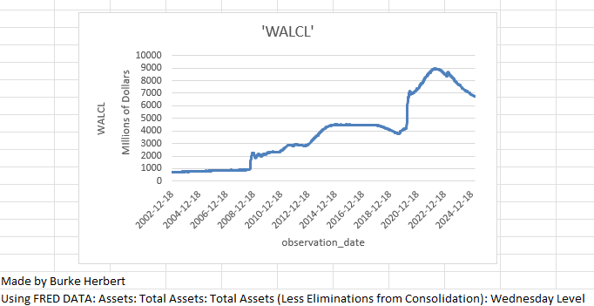 As shown in the graph, both quantitative tightening and easing are relatively new monetary policies, as the total assets of the Fed only began to increase during the 2008 financial crisis. Total assets would once again increase dramatically in 2020 during the COVID era. This graph also shows that most recently, together with the lowering rates of inflation, the Federal Reserve has once again been selling off its assets. Another tool used to anchor inflation is the interest rate the federal reserve pays the banks or the IORB. The IRB can be used as a monetary policy tool to cause banks to hold on to their reserves rather than lend more and cause the economy to inflate. Before 2008, buying and selling off assets in the federal reserve was a way to control the IORB through the federal funds rate. Due to the new adoption of quantitative easing and quantitative tightening this link between the federal funds rate and the IORB has reduced greatly. 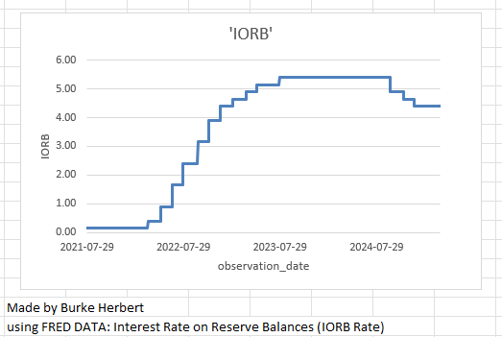
This graph shows that in recent months, from late 2024 to the current day the IORB rate still remains relatively high. This is important and interesting, considering the median consumer price index shows that inflation is still going down. These three graphs show that the IORB rate and collection of federal reserve assets are both in historically high and unnatural positions. This, coupled with the fact that inflation is still at a high annual change rate, puts some doubt on the idea that the Federal Reserve is the core driver of inflation.
The Federal Reserve is currently using an extremely restrictive monetary policy that it has not done in decades. After the use of a high IORB rate and a massive increase in the balance sheet through the procurement of assets, the Federal Reserve is now beginning to try to combat inflation. Its policy is centered around keeping the interest rate reserve balances fairly high and implementing a quantitative tightening program by aggressively reducing its assets. These policy tools together are used in the hope of cooling consumer demand and restoring price stability. Firstly, the Fed is using a high IORB rate to try and keep banks from providing and lending more of their reserves to the economy by restricting the amount that banks can lend out to consumers and businesses. By restricting the amount of money in circulation, the Federal Reserve is making financial conditions more difficult in the hopes to drive down excessive borrowing and spending. The problems of excessive borrowing and spending were two major contributors to inflation during the COVID pandemic era. The IROB is being used as a floor for interest rates so that credit becomes more expensive and is used less in the economy. Secondly, the federal reserve is also implementing the tool of quantitative tightening to restrict the liquidity in the market overall. Allowing treasury securities and mortgage back securities to mature without reinvestment causes a passive rolloff and removes liquidity from the financial system. Restriction of previously sought-after securities once again puts pressure on the economy for less borrowing. By using these policy tools, the federal reserve hopes to achieve its primary objective of bringing inflation back to its long-run target of ’’inflation at the rate of 2 percent” (Statement on Longer-Run Goals and Monetary Policy Strategy). This is a very important goal for the Federal Reserve to achieve, especially after coming off of its highest inflation rates in four decades in 2022. By putting more financial pressure on the economy through high IORB and quantitative tightening, the Federal Reserve hopes to decrease total demand and thus slow down inflation. Bringing inflation back down to its long run goal of 2% is seen as almost a necessity for the Federal Reserve because if the Fed cannot reestablish its credibility as being a driving force of economic stability, it will lose its ability to anchor and manipulate inflation. However, if the Federal Reserve pushes these policies too far, it can inadvertently cause a prolonged recession, which would not only damage the economy greatly but also reinforce distrust in the Federal Reserve itself. In the short run, these policies will contribute to tighter credit conditions and slow down consumer spending. While inflation has gone down recently, it still remains very high above the Federal Reserve target. However, there is another issue the Federal Reserve must address. How can they continue these policies in the long run and avoid a recession while also reducing and fixing the damage done by the historically high inflation rates caused by the Covid pandemic?
While both the Federal Reserve's high IRB rates and its use of quantitative easing has caused inflation to fall, it has placed a heavy burden on the consumers and the demand side of the economy. This approach adds a risk of a depression, stalling the economy’s momentum and putting financial pressure on Americans. Due to these issues, I argue for a third pillar of monetary strategy to be implemented along with these last two policies. This third pillar is the introduction of a strategic supply reserve system that targets inflation by stabilizing the cost of essential inputs. By stabilizing the price of key goods, the SSRS will provide a more balanced approach to reducing inflation and supporting long-term economic growth. The strategic supply reserve system should be modeled after the strategic petroleum reserve, and it would consist of national stockpiles of critical goods such as fertilizer, grains, copper, lithium, and even semiconductors. By having a back-up supply of these goods, the Federal Reserve gains an asset that can reduce supply shocks coming from our own economy and foreign economies. During inflationary periods, the SSRS could be used as a monetary tool to drive down prices for producers and thus prevent cost increases from reaching consumers. The SSRS could also be used during periods of low inflation or deflation as a way of stockpiling essential goods to prepare for a future of volatility. This system will allow the Federal Reserve to fight inflation without solely relying upon consumer expectations and manipulation of the money supply. The implementation of the strategic supply reserve system would require a new federal body, which should be called the monetary supply stabilization board. The MSSB‘s core function would be to monitor inflationary pressure tied to specific commodities and manage the release and stocking accordingly. The board would have to operate under a rule-based framework that would use inflation thresholds. For example, if inflation increases to a high rate, the MSSB could authorize a release of certain goods or commodities to stabilize the economy. Conversely, in periods of deflation, the MSSB could purchase goods to replenish its reserves. This system would rely on real-time supply chain data and market price tracking. It in no way could replace monetary policy tools like the IORB or quantitative tightening, but it could be used as a balancing mechanism to impose monetary policy on the supply side of the economy. By buying assets/goods this also allows the Fed to record a different form of asset on their balance sheet that cannot be as easily liquidated as in the case of securities. In the short term, the SSRS would allow the Federal Reserve to target cost push inflation more precisely instead of relying solely on a reduction in borrowing and investment. In the long term, the SSRS would make the US economy more resilient and self-reliant by having a reserve of strategically important goods, thus lowering dependence on unstable foreign supplies. Also, having higher stockpiles of different goods could also increase the trust and credibility in the system of the federal reserve in the eyes of the American public.

