Construction Management
Profile Path Report
Burke Herbert

Executive summary:
The point of this project is to provide myself with an overview and a plan of what field or career that I would like to go into after college. This project is also made to provide an overview of my progress towards my future career and future life plans to my Dad, who is the most interested person in my career and my main benefactor. This project will feature a career path profile for construction management. This career path profile will cover the construction management feasibility and benefits for me, three ad examples for construction management, and an overview of what steps will be needed to take to pursue this path. This project will also feature an outline of the work as completed and plan to complete to secure this path, as well as a timeline to show my milestones for completing this path. Lastly, this project will also cover the cost and required resources I will need to continue down this path.

Table of Contents:
Contents
Executive summary: 2
Table of Contents: 3
Introduction: 4
Background: 5
Career path profile: 6
Feasibility and Benefits: 6
Three ad examples: 7
Conclusion: 8
Work Completed and Proposed: 9
Remaining education, training, and certification: 9
Internships and experience: 9
Schedule: 11
Costs and Required Resources: 12
Conclusion: 13
Appendices: 14

Introduction:
The point of this report is both a status report, and a proposal for my education and career path. It is a status report because it will cover the work that I have completed to pursue this path as well as the work that is needed to complete for me to attain this path. It is also a proposal as I will need support to pursue this path, thus this report will be used in hopes of gaining that support from you. The path that I have chosen for my career and will cover for this project is a field I have worked in for a while under your supervision, and we have talked about my plans to move into this field since I first began working. I hope you find the details in this report as an appreciation of the time and resources you’ve already invested in me. The rest of this report will be an overview of the field of construction management, and what I will need to do to enter this field. Firstly, I will cover the background of why I chose this field, then I will cover a basic career profile for this field, and lastly, give an overview of the work I’ve completed to pursue this field in the work left to complete.

Background:
The initial need for creating this report is the complete assignment in my technical writing class. The purpose of the assignment is also to help me prepare for the future, but also a way for us to gain experience in formulating reports that overview future projects and plans. My technical writing class is a class needed to fill my English minor. This minor is also paired with my Economics major. I chose an Economics major and an English minor because TCU did not offer any form of construction major or minor, and honing my abilities in both of those academic fields would help me in any part of my life. I chose construction management as my career path because I knew I wanted to do something in construction and in business. The first job I hope to have after college is working for your company, so I can learn more about construction and how the business works. The end of my career path is that one day I hope to own a construction company.

Career path profile:
The career of construction management can be defined as a service that manages projects and overviews job sites to provide project owners with effective management of schedule, cost, quality, safety, scope, and function. Another definition of construction management is the leadership of the workers or the team that is involved in a construction project. In the next part of this report, I will go over the feasibility and benefits of construction management as a career path, I will give three ad examples of jobs in construction management looks like, and I will define what I will need to do in the future to begin and follow this career path.

Feasibility and Benefits:
I think that this career path is extremely feasible for me. I think this because I’ve been working in construction and infrastructure jobs since I entered the workforce. Throughout my time working for the construction company I have learned about different sectors of a construction company. The equipment shop I have worked in oversaw and interacted with many different parts of the construction company. It was our job to provide equipment and understand what was needed on the job sites. Not only did I learn about different sectors of a construction company in the vehicle shop, but I’ve also refined my ability to work with others in that field. I have had to lead my own projects that I was assigned, and I have been led in projects that I was given. Due to this fact, though I do not claim to have a complete understanding, I have some experience and understanding of what leadership means in the field of construction. To be educated and ready for this job I will need “A bachelor's degree is often the minimum education requirement to become a CM.” (Indeed) Employers, also desire the relevant work experience in construction when hiring someone for construction management. In another Indeed article it is stated that a “construction project manager is constantly multitasking, maintaining excellent organization is crucial to ensure everything runs smoothly.” (Indeed) These qualities not only apply to a construction manager but also to an efficient leader in general. The outlook and pay for a construction manager also knownto be very good. The Bureau of labor statistics claims that “The median annual wage for construction managers was $104,900 in May 2023” and that “Employment of construction managers is projected to grow 9 percent from 2023 to 2033” (Bureau of Labor Statistics) these statistics show that the career field for construction manager not only pays well but is also a growing field. I believe that this career path is also extremely meaningful to society. Since the dawn of civilization, people have needed shelter and roads, the modern day is no different. The benefits of this career path include stability, good pay, and a job that can bring purpose to life.

Three ad examples:
To better understand the requirements and benefits of this field, I looked through three different ads for construction managers that I found on ZipRecruiter. All three of these job ads can be seen fully in the appendices of this report. The first job ad I saw was for the Mary Greeley Medical Center as a construction coordinator. The responsibilities of this job are to oversee all construction for Mary Greeley and to negotiate agreements with all architects, consultants, and contractors on Mary Greeley’s behalf. This job is hourly, but the ad does not specify the hourly rate for the position. This job also requires a bachelor's degree in construction or a related field and requires at least eight years of experience in coordinating construction. The second ad is a facilities construction manager for Iowa State University. This job, like the job for Marry Greeley Medical Center, is to oversee all construction projects on behalf of Iowa State University. The exact pay grade for the job does not seem to be specifically listed. The minimum qualifications for the job or a bachelor's degree in five years of related work experience. Unlike the ad for Mary Greeley, this ad has a section on why you should choose to work at Iowa State University. The last advertisement is for a construction senior project manager/estimator for Dean Snyder Construction Co. This job differs from the other two jobs, in that the manager is not to work on behalf of the owner, but it’s to work with the owner, as well as the superintendents. This company requires a bachelor's degree in construction or any related field, and 12+ years of experience in the field, which is the longest requirement out of the three adds. The advertisement once again does not offer any specific pay amount, but rather says that itis weekly pay. The advertisement also has a section on what they offer, which includes things like information on their medical and dental plans, and information about paid holidays. By looking over these three ads, I’ve taken away that having some form of degree in construction is worth considering but more importantly, making sure I have adequate years of experience is a necessity for the career path.

Conclusion:
After doing research on the feasibility of this career path and looking at advertisements for this career path, I have come up with a standard plan on how to begin this career. Firstly, getting as much experience in the field, and in construction is a necessity for this career path. Experience in a construction environment is a necessity, but also experience in a managing environment is very important as well. Secondly, considering another degree besides, my economics major might be worthwhile.

Work Completed and Proposed:
In his last two sections, I will describe the completed education, the remaining education, and the experiences I will need to be successful and pursue this career path.

Remaining education, training, and certification:
The education that I have already completed for this career path is a bachelor's degree in economics. In pursuit of this bachelor's degree, I’ve improved my ability to write as well as understand finances. Two classes in particular from my time getting this bachelor's degree that I think will be critically important in this career path will be my technical writing class and my fundamentals of accounting class. To complete my major and earn my bachelor's degree I have a total of 10 classes left. I plan on completing six of these classes by the end of the spring semester and completing the last four classes over the summer semester. After getting my bachelor's degree. My next steps to furthering this career path are getting certified for estimation and considering getting a degree in construction management.

Internships and experience:
My previous and current experience is more detailed in my résumé, which I have provided in the appendix of this report. To further myself and gain more experience in this field I will continue to work at my dad’s construction company but hope to find myself in positions where I can better understand the management, aspect of the company and the estimation side of the company. I have learned a lot about equipment and the maintenance of equipment from my experience working in the vehicle shop. I plan to expand my responsibilities towards the operations side of the company, so I can gain a better understanding of how to run a job site and how to manage construction.

Schedule:
This is my Gnatt chart for pursuing the career path of construction management. I first plan on getting my Bachelor’s Degree and then I will return into the work force. I don’t plan on initially starting on further educating myself until I have settled my occupation. I also think it would be wise to take time to gather the funds needed for my education.
Task | Fall 2024 | Spring 2025 | Fall 2025 | Spring 2026 | Fall 2026 | Spring 2027
Get Bachelor’s Degree
Get experience at Construction Company
Further my Education

Costs and Required Resources:
The material support I will need to advance in this career path consists of networking, and saving money. The education needed to become a construction manager is not extremely expensive, however, the education is not free. Therefore, I will need to save up money and manage my finances correctly so that I can afford the best education in this field. I will also need to network to further myself down this path. Networking will generate opportunities for getting more experience in the field of construction.

Conclusion:
I have already started working towards this career path, and I’ve done so at a very early age. Since I am already planning on working in a construction company, and I am planning on expanding my responsibilities to that construction company after college this career path seems very feasible. I plan to continue to educate myself as well as finish the education that I have already started. I also plan to seek out more opportunities and more experiences in the construction business sector. I hope to talk with you more about this and learn from your experiences about how I can further prepare myself for this career path.

Appendices:
1st ad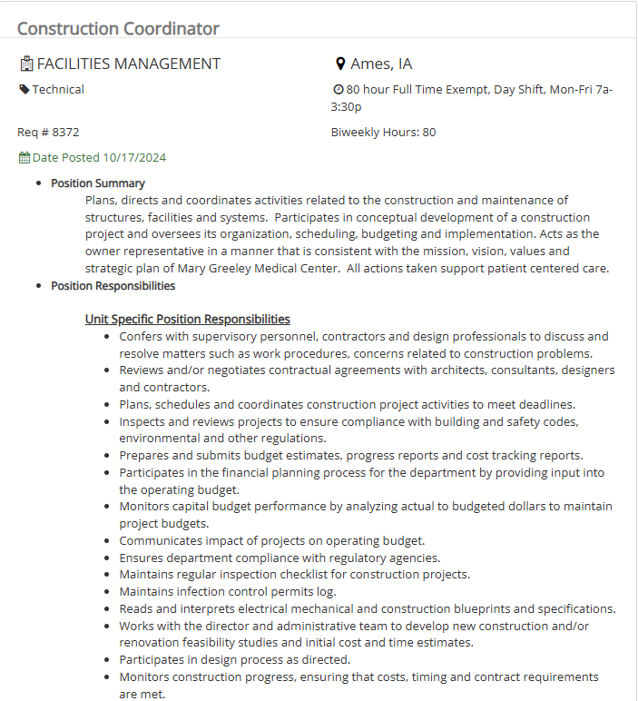
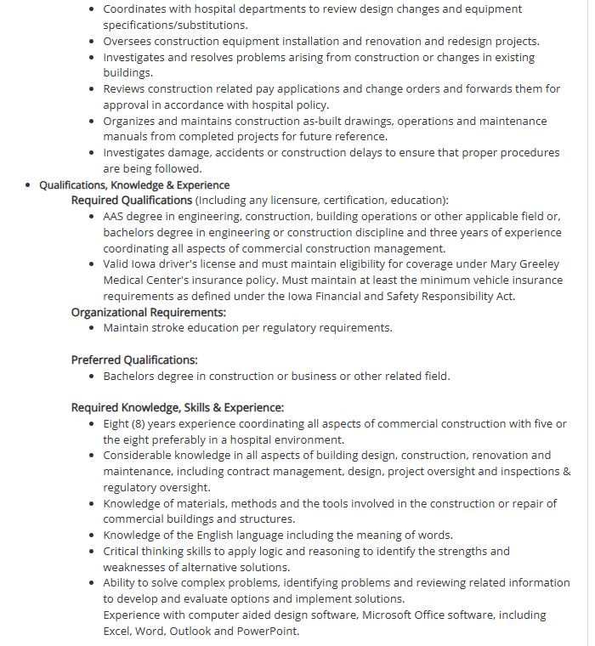

2nd ad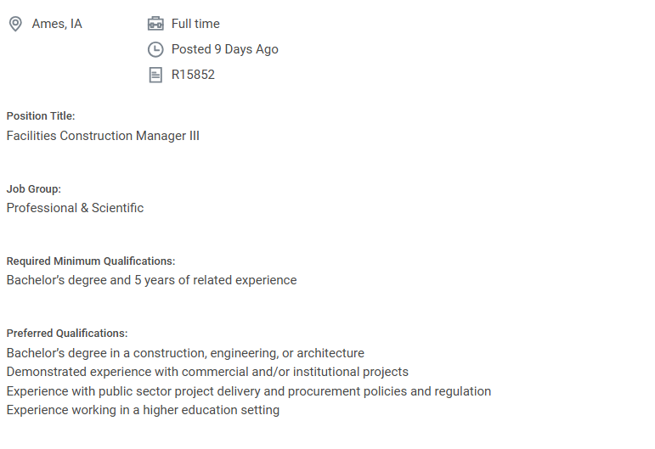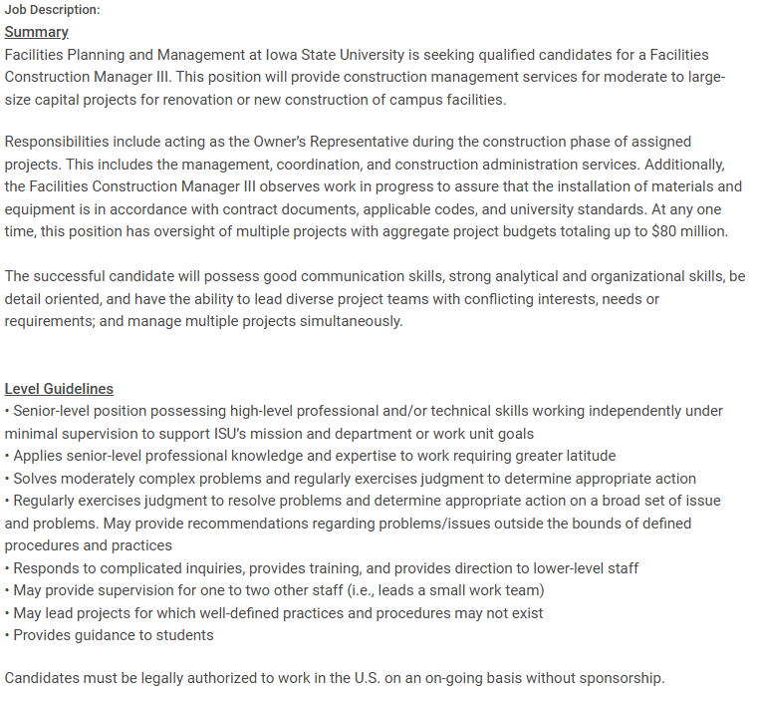
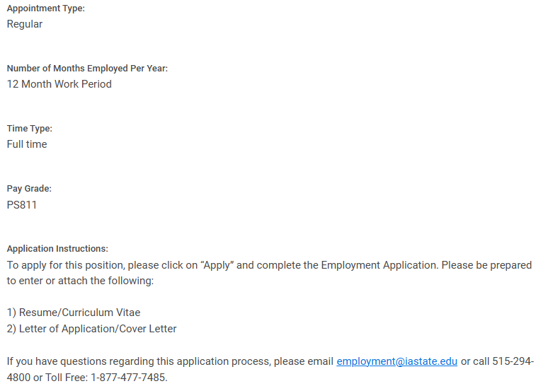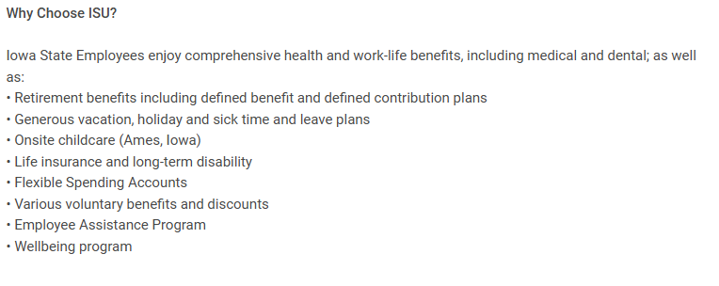

3rd ad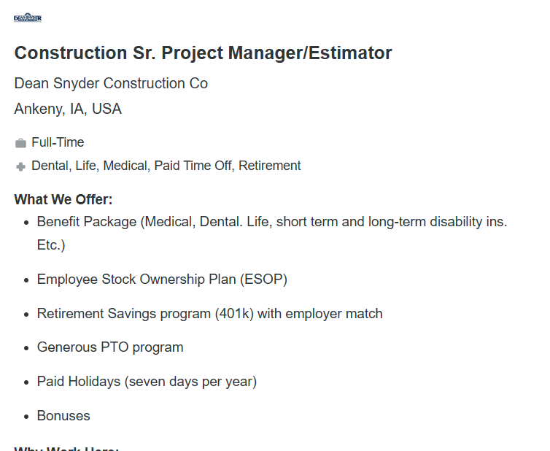
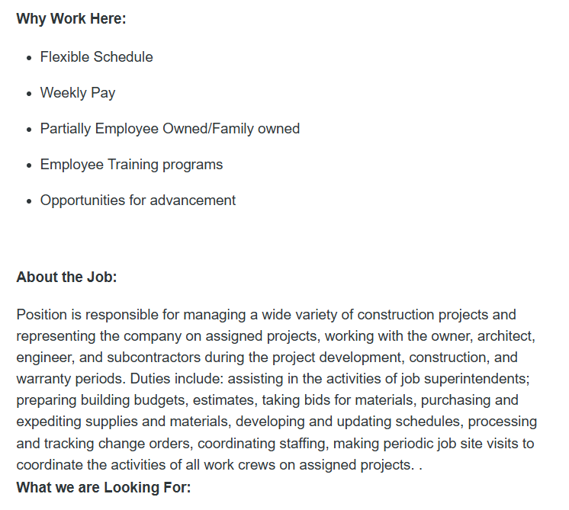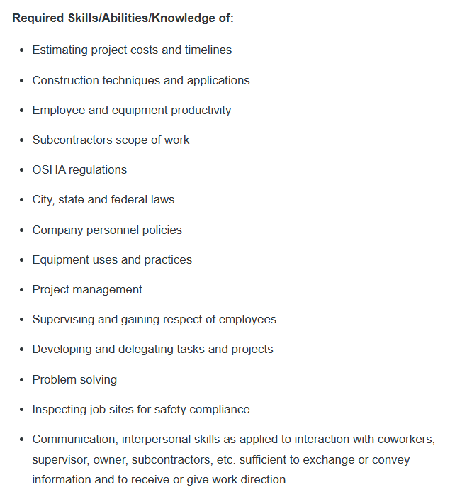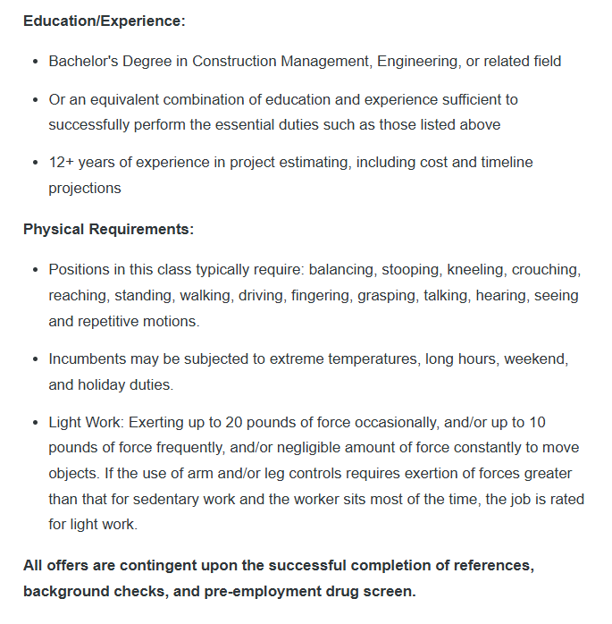

Resume
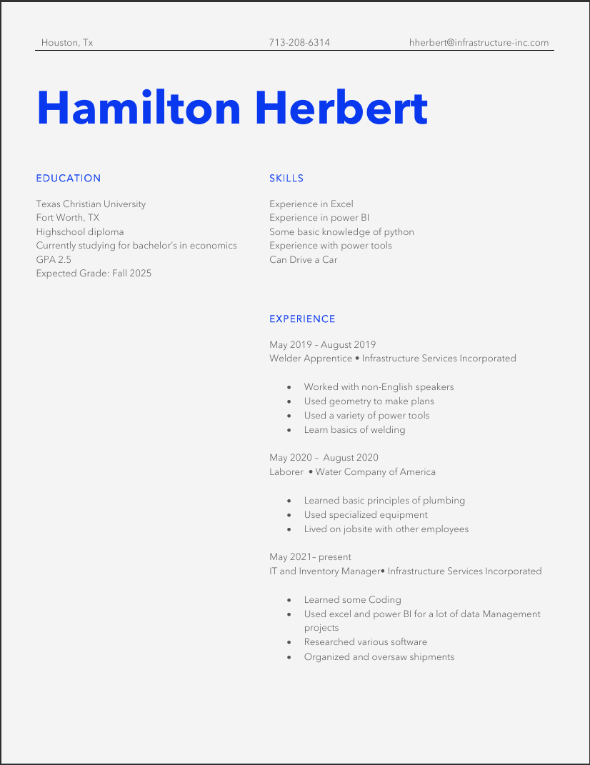
Work Cited:
How to become a construction manager: A complete guide | indeed.com. (n.d.). https://www.indeed.com/career-advice/career-development/how-to-become-a-construction-manager
Nevogt, D. (2024, September 10). 11 skills you need to be a good construction manager. Hubstaff Blog. https://hubstaff.com/blog/construction-management-skills/
U.S. Bureau of Labor Statistics. (2024, August 29). Construction managers. U.S. Bureau of Labor Statistics. https://www.bls.gov/ooh/management/construction-managers.htm

